

G L BAJAJ INSTITUTE OF TECHNOLOGY AND MANAGEMENT, GREATER NOIDA

A Project Report
On
HackShield
Submitted in partial fulfillment of the requirement for the award of the degree of Master of Computer Applications
By
Himanshu Khatri
Roll No. – 2301920140068
Under the Supervision
of

Mr. Akhilesh Nagar
(Assistant Professor)



DR. A P J ABDUL KALAM TECHNICAL UNIVERSITY, LUCKNOW
(2024-25)

PROJECT REPORT ON

HackShield

(KCA-451)
Session-2024-2025

Department of Master of Computer Applications (MCA)



Submitted to: Submitted by:
Mr. Akhilesh Nagar Name: Himanshu Khatri
(Assistant Professor) Roll no: 2301920140068
Semester: IV
Section: A2

G L Bajaj Institute of Technology & Management
Plot No 2, APJ Abdul Kalam Rd, Knowledge Park III,
Greater Noida, Uttar Pradesh

ACKNOWLEDGEMENT

Himanshu Khatri
(2301920140068)

CERTIFICATE OF ORIGINALITY

I hereby declare that my Project titled “HackShield” submitted to Dr. APJ ABDUL KALAM TECHNICAL UNIVERSITY, Lucknow for the partial fulfillment of the degree of Master of Computer Applications Session 2024-2025 from G L Bajaj Institute of Technology and Management, Greater Noida has not previously formed the basis for the award of any other degree, diploma or other title.

Place: Greater Noida Signature
Himanshu Khatri
Date:

CERTIFICATE OF ACCEPTANCE
This is to certify that the project entitled, “HackShield” submitted by Himanshu Khatri a Bonafide student of G L Bajaj Institute of Technology and Management, Greater Noida in partial fulfillment for the award of Master of Computer Applications affiliated to Dr. APJ ABDUL KALAM TECHNICAL UNIVERSITY, LUCKNOW during the year 2024-25. It is certified that all corrections, suggestions indicated as per Internal Assessment have been incorporate in the project.
To the best of our knowledge, the work embodied in this report is original and has not been submitted to any other degree of discipline. The project report has been approved as it satisfies the academic requirements in respect of Project work prescribed for the said degree.

[Sign and Name of Internal Guide] [Sign of External Examiner]

Head of Department
Master of Computer Applications
G L Bajaj Institute of Technology and Management, Greater Noida

TABLE OF CONTENTS
ACKNOWLEDGEMENT……………………………………………………………………. i
CERTIFICATE OF ORIGINALITY………………………………………………………… ii
CERTIFICATE OF ACCEPTANCE………………………………………………………… iii
TABLE OF CONTENT……………………………………………………………………… iv
LIST OF FIGURES…………………………………………………………………………...v
LIST OF TABLES…………………………………………………………………………….vi
Chapter 1 1-2
Introduction and Aim of the Project
Chapter 2
Background Study and Research Gap 3-5
Chapter 3
Tools/Platform, Hardware and Software Requirement Specification (DFD, ER) 6-7
Chapter 4
Proposed work and Methodology 8-11
Chapter 5
Design/Development 12-17
Chapter 6
Testing and Implementation 18-20
Chapter 7
Result and Discussion 21-23
Chapter 8
Conclusion and Future Scope 24-26
REFERENCES 27

LIST OF FIGURES

Chapter 1
Introduction and Aim of the Project
1.1 Introduction
With a rapid increasing rate of cybercrimes at alarming levels, digital forensic science nowadays is playing an important role in tracking, investigation, and maintaining electronic evidence to utilize it at investigation and even court hearing. With the increasingly looming threat of new age threats like ransomware, phishing, data breach, and cyberbullying, it becomes essential that uncomplicated easy-to-use digital forensics toolkits must be easily accessible. Most solutions currently are either platform-specific (i.e., desktop-based) or not readily available to general users, teachers, and researchers who require web-based and user-friendly solutions.

HackShield is a browser-based Digital Forensics Kit aimed to fill this void with a centralized, accessible, and functional interface to perform initial digital forensics analysis. Contrary to the conventional forensic tools that comprise time-consuming installs and loads of technical know-how, HackShield boasts an interactive user-friendly interface where users are able to realize basic forensic functionalities in their browser.

The site is developed using JavaScript, CSS, and HTML for the interactive, dynamic front-end and Python (Django) back-end, with robust libraries and modules for file analysis, hashing, metadata examination, data analysis, and encryption processes.

HackShield is designed as a lightweight, modular platform for students, researchers, cyber-analysts, and field investigators requiring instant access to forensic instruments without compromising on functionality or ease of use.

1.2 AIM:
The main goal of the HackShield project is to create an integrated browser-supported Digital Forensics Kit with the capability of delivering the user the functionality of undertaking preliminary forensic analysis, digitally preserving evidence securely, and supporting cyber investigation in the browser platform.
Main goals are:
- To create an easy to use and accessible web interface to conduct forensic operations like file integrity check (hashing), metadata extraction, encryption/decryption of a file, and log analysis.

- To make backend forensic capabilities Django and Python library compatible like hashlib, prefix, cryptography, and os to enhance scalability and security on the platform.

- To give it cross-platform compatibility by removing the dependency on platform-based desktop tools and giving it a cloud-accessible solution.

- To educate students and beginner cybersecurity professionals further about it and make it more interactive with module-based documentation inside the tool.

- To facilitate easy ethical and safe practice of computer forensics through an integration of the evidence protection and tamper identification features.

By accomplishing these objectives, HackShield would aspire to enable users of great forensic capability in a friendly web-based environment and thereby make their contribution to the cause of world digital security and awareness.

Chapter 2
Background and Research Gap
2.1 Background:
Digital forensics became the core of cybersecurity, police investigation, and legal investigation. As digital hardware and web network got a common routine feature of life, volume and count rose several folds. Application software like FTK, EnCase, Autopsy, etc. proved to be highly useful in reconstructing and analyzing device information. These tools are costly, resource-hungry, and need proper domain expertise for their successful implementation.

On top of that, all of the traditional forensic software are desktop applications and platform-specific and hence restrict their usage to individuals who own not-so-fast computers or use machines. Furthermore, a few of them are non-modular and thus the users will be compelled to install massive software bundles in the event they need to take advantage of merely a slender capability like file hashing, metadata removal, or cryptography tools.

Other than this, internet technologies have come such a long way that now browser applications can be utilized to achieve things which before were achievable only for desktop applications. Due to backend frameworks like Python-based Django, now it becomes possible to create secure, scalable, and modular forensic tools which an end user can remotely utilize over the internet.

There is a growing need for easy-to-use digital forensic environments and training. As there is a growing need for cybersecurity training, junior professionals and students require easy-to-use environments to test and learn with forensic processes easily without the inconvenience of sourcing expensive commercial tools or setting up complicated environments.

2.2 Research Gap
Despite the intense need for digital forensics in the modern world, there are research gaps and today's available tools that HackShield aims to address:

- Inaccessibility of Web-Based Forensic Tools
Most tools available are closed-source or offline-based. There is no availability of web-based tools with necessary forensic features in a suitable format for instant investigations, learning, or remote analysis.
- Sloping Learning Barrier for New Students
There must be minimal modularity and personalization since standard forensic kits require hands-on expertise in forensic science, file systems, and environments of some tools. That is too steep a learning curve for starters or cybersecurity beginners. There must be an easy, streamlined interface that graphically and intuitively presents basic forensic functionality.
- Minimal Modularity and Personalization
Most of the utilities are either too general or too specialized with packages that are too large or scope too narrow. There is a requirement to provide modular, extensible platforms where one can choose and employ only the forensic utilities needed
- No Real-Time or Cloud-Available Investigation Kits
In the vast majority of real-world instances, the examiners need to operate in low products or even off-site but not necessarily high-grade hardware. There are no or barely any such solutions around, and none are constructed with the intent of use within a browser. One that can be remotely accessed over the cloud and can also function on smartphones would be filling the gap.
- Lack of Integration Among Forensic Functions
Most of the software that exists is function-siloed—i.e., one to hash, one to handle metadata, one to encrypt—without there being some sort of overarching platform that integrates them all together into a cohesive experience. That fragmentation disrupts investigation workflows and makes productivity take a hit.

HackShield seeks to bridge these gaps by developing a lightweight, modular, and simple-to-use web application that carries out required digital forensic actions with an educational and straightforward approach. Relying on Django and the rich Python ecosystem, the project bridges the gap between the classic desktop-focused forensic analysis and the web-focused alternatives of today.

Chapter 3
Tools/Platform, Hardware and Software Requirement
Tools/ Platform Used
Category | Tool/ Platform | Purpose
Frontend | HTML5, CSS3, JavaScript | For designing responsive and interactive web pages
Backend | Python, Django Framework | Core backend logic, APIs, routing, and data processing
Libraries | Haslib, cryptography, os, pyexif | For hashing, encryption file, file system task, and metadata extraction
Database | SQLite/ PostgreSQL | For user authentication and storing investigation logs
Authentication | Django’s built-in authentication system | For secure login, user roles, and data protection
IDE | VS Code | Development and debugging of frontend and backend code
Version Control | Git + GitHub | Source code management and collaboration

Hardware Requirements
Component | Minimum Requirement | Recommended Requirement
Processor (CPU) | Dual Core 2.0 Ghz | Quad Core 2.5 GHz or above
RAM | 4 GB | 8 GB or above
Storage | 2 GB | >5 GB
Network | Internet Connection | Stable Broadband
Display | 720p resolution | 1080p or higher

Third-Party Libraries Used
Library | Purpose
Hashlib | To generate cryptographic hash functions
Cryptography | For encrypting and decrypting file securely
Pyexif/PIL | For extracting image metadata such as GPS, timestamps
Os, shutil | File system and environment interactions
Django.contrib | Built-in modules for authentication, sessions

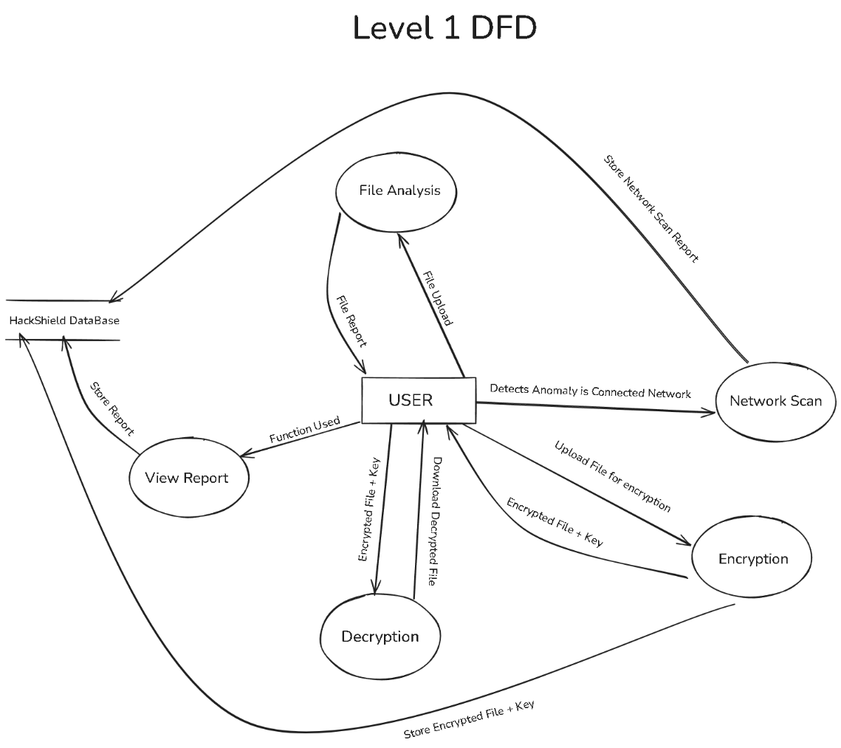

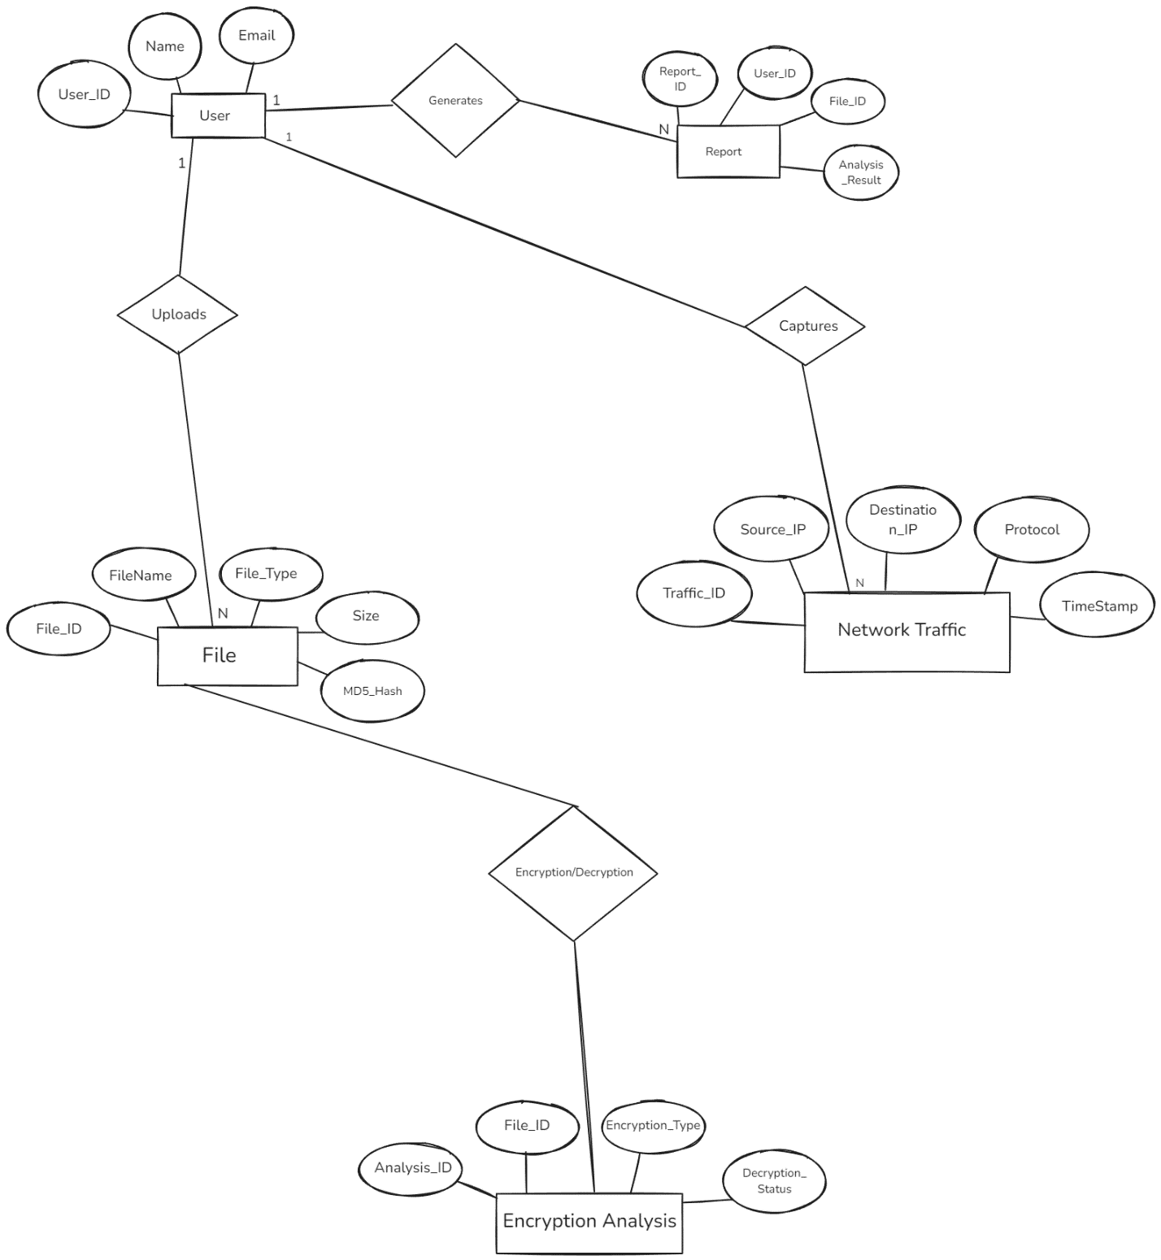

Chapter 4

Purposed Work and Methodology
The system developed, HackShield, will be a web-based Digital Forensics Kit to make forensic tools readily available in one location. The website will be designed to help students of cyber security, ethical hackers, lecturers, and investigators make the forensic process simpler and convenient by automating it without frequent installations or platform-specific software.

The system will have numerous features such as:
- File Integrity Verification via hashing techniques (MD5, SHA-256).
- File Metadata File and image recovery.
- File encryption and decryption with strong cryptography techniques.
- Basic scan of logs and files for changes or abnormalities.
- User session control and authentication for secure and personal access.
- Modular architecture to support further integration with other forensic tools like timeline analysis, registry analysis, or packet analysis.

All functionality will be accessed via a simple and intuitive HTML, CSS, and JavaScript-based web interface, server-side and backend operations will be handled via Django (Python). The app will also have a simple database to monitor user activity and hold forensic reports for audit purposes.

4.1 Methodology
HackShield shall be written in a modular and flexible fashion, splitting the system into stand-alone modules, which are developed and tested in step-by-step manner.

1. Requirement Analysis
- Identify key user roles (e.g., Admin, Investigator, Student).
- Identify minimum functionality for a Minimum Viable Product (MVP).
- Select frontend libraries and tools, backend libraries and tools, encryption tools, and data processing libraries and tools.

2. System Design
- Frontend Design
- Design clean pages using HTML and CSS (dashboard, upload space, report viewer).
- Use JavaScript for such interactive operations as form submission, view switching, dynamic output.

- Backend Design:
- Apply Django's MVT (Model-View-Template) design pattern.
- Apply one model per utility (i.e., hash, encryption, metadata).
- Apply one view per utility (e.g., hash, encryption, metadata).
- Apply models for user data, file action logs, and report storage.

- Database Design:
- SQLite (dev) or PostgreSQL (prod).
- Models are: User, FileActionLog, GeneratedReport
3. Testing and Debugging
- Unit Testing for each module utilizing Django test framework.
- Manual Testing for frontend responsiveness and UI bug.
- Security Testing to prevent file injection, access control vulnerability, and CSRF attack.

4. Deployment
- Final project hosted at PythonAnywhere, Render, or Heroku.
- Static files (CSS, JS) served via Django's static file server.
- Backend database integrated with a live environment (PostgreSQL or SQLite).
- Basic monitoring and logging turned on for performance monitoring.
5.Module Development
Module | Technologies Used | Functionality
File Hashing Tool | Python haslib, Django forms | Computes MD5, SHA-1, SHA-256 hash of uploaded files
Metadata Extractor | Pyexif, PIL, os | Extractes images/document metadata such as GPS timestamp, device info
File Encryption | Python cryptography | Encrypts uploaded files and generates a secure decryption key
File Decryption | Python cryptography | Allows user to upload an encrypted file and use the key to decrypt
Report Generator | Django Templates | Shows processed information

Development Workflow Diagram
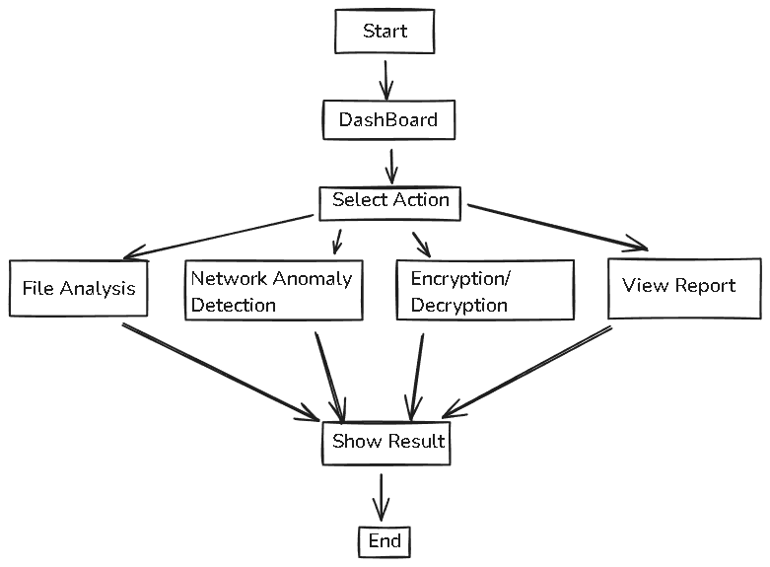

Chapter 5

Design/Development
HackShield is coded on top of Django's Model-View-Template (MVT) framework. Architecture is extensible and modularized — so much so that it is possible to integrate new tools into the system without touching the inner core framework.

5.1 Design Principles
- Separation of concerns: Frontend, backend, and logic layers are distinct.
- Modular development: Each tool is a self-contained module.
- Security-first: Tools process user files securely with in-memory processing.
- User-friendly UI: Clean view dashboard easy to use with immediate feedback.
Module 1: File Integrity Checker
Purpose:
Validation of integrity of a file by calculating its special hash value. It is useful to detect if a file is open or not.
Functionality:
- Processes user-uploaded file.
- Generates hash value for MD5, SHA-1, and SHA-256.
- Hash values are reflected in real-time on UI.
- Hash-to-clipboard download and to local text file download.

Technology Stack:
- Python's hashlib for server-side calculation of hash.
- JavaScript for real-time interactivity on client-side.

Use Case
Mainly applied to the integrity verification of a file during the download, backup, or even gathering of forensic evidence.
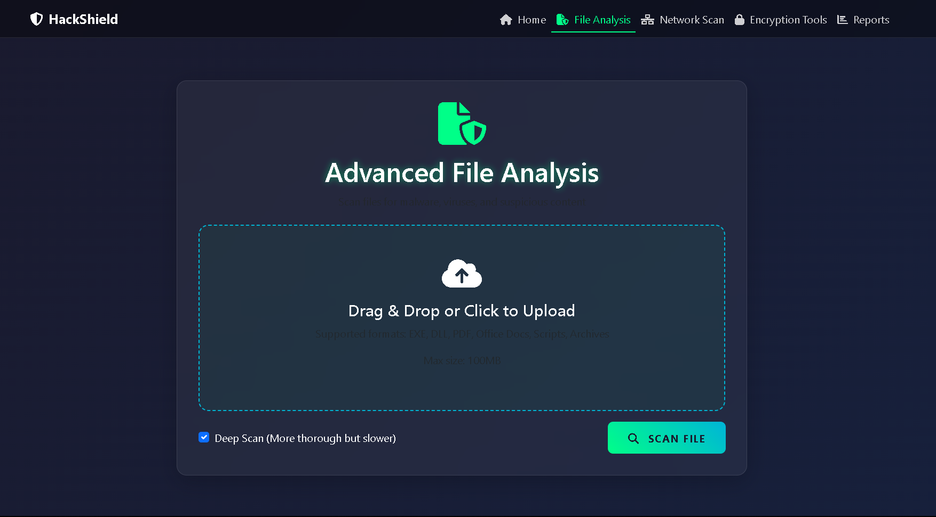
Module 2. File Encryption Tool
Purpose:
To allow all the users to encrypt files securely with the use of AES-based encryption, preventing unauthorized access to vital data of the user.
Functionality:
- Takes file as input and a secret key from the user.
- Applies the Fernet(AES-based) encryption algorithm to the user uploaded file.
- Returns an encrypted file.
- User can download the encrypted file and view/save the encryption key.
Technology Stack:
- Python cryptography.fernet for symmetric encryption.
- Django forms for secure file and key input handling.
Use Case:
Securing vital data of user during the transfer, storage, or forensics analysis.
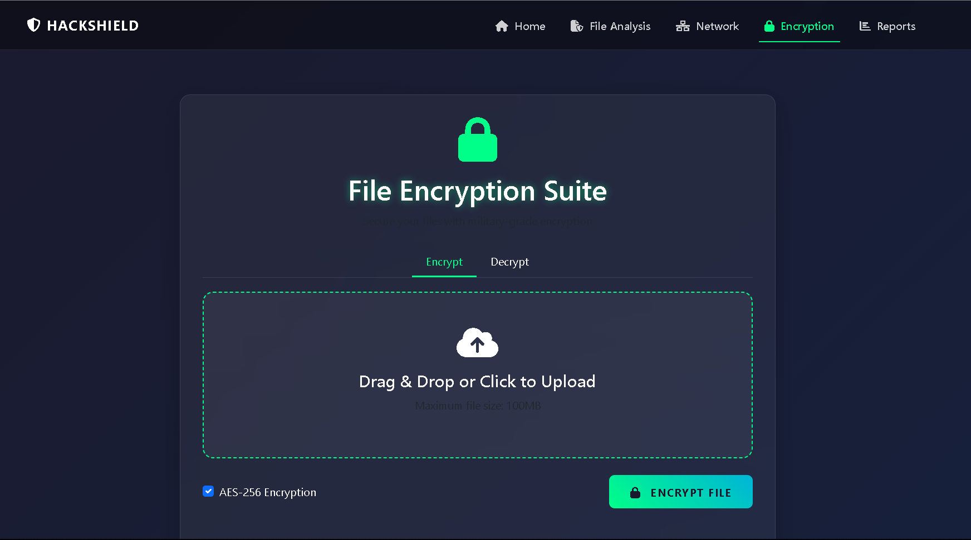
Module 3. File Decryption Tool
Purpose:
Decrypts a given encrypted file into its original form using the proper decryption key.
Functionality:
- Takes an encrypted file and key input from the user.
- Decrypts the file and validates the key on correctness.
- Returns the original file to be downloaded.
Technology Stack:
- Python cryptography.fernet to be utilized for decryption.
- Exception handling for verifying misplaced/wrong keys.

Use Case:
Reverses the encryption process to decrypt digital evidence or recover critical information.
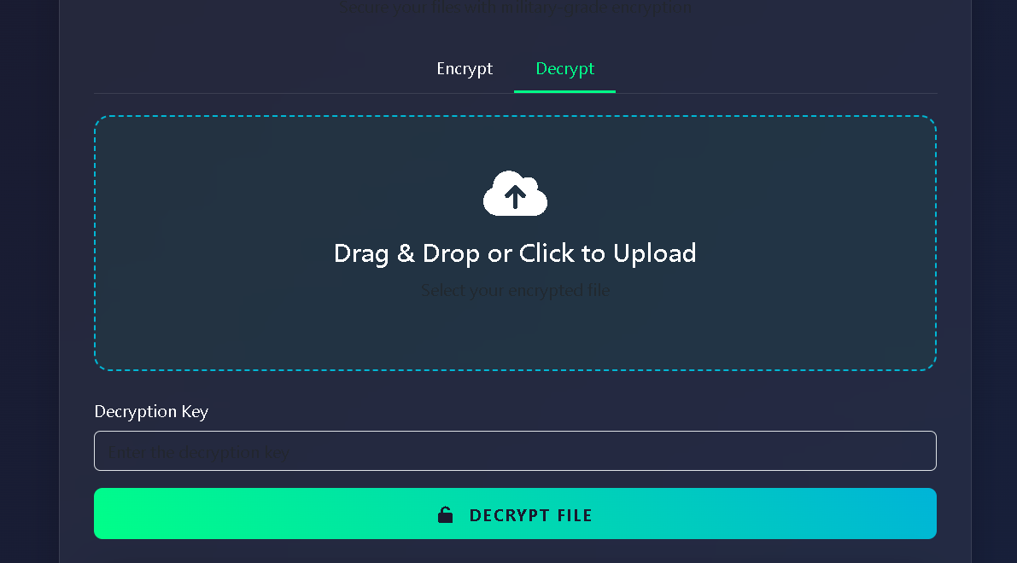

Module 4. Network Anomaly Detection
Purpose:
Scans the network to check any threats or anomaly present in the connection.
Functionality:
- Click on Scan network button
- The site will start network scan and check the IP address
- Display the result of scan with threats if any.
Technology Stack:
- WireShark
- Pandas(Python Libraries)
- Scapy
Use Case:
Scans the public network for any hijacking to stealing of data .
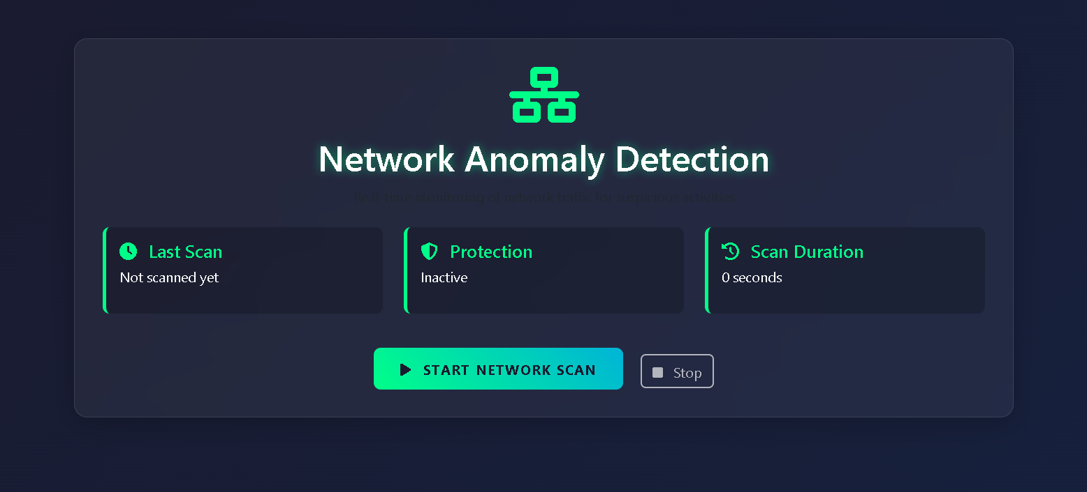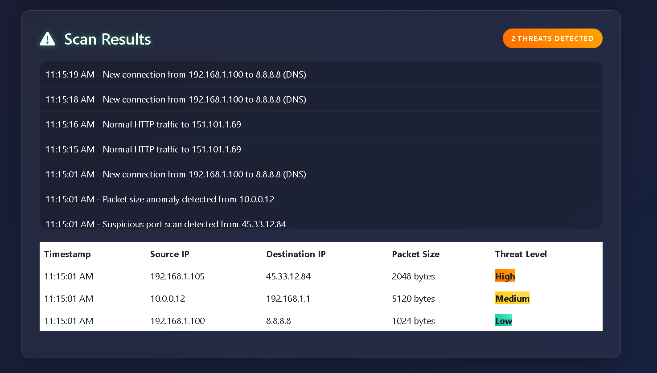
Module 5. View Reports
Purpose:
Display the reports of what functionality has been used by the user.
Functionality:
User can check the report of what function he/she has used recently
Technology Stack:
Django, Python (reportlab/xhtml2pdf)

Use Case:
Provide detailed report of the actions performed
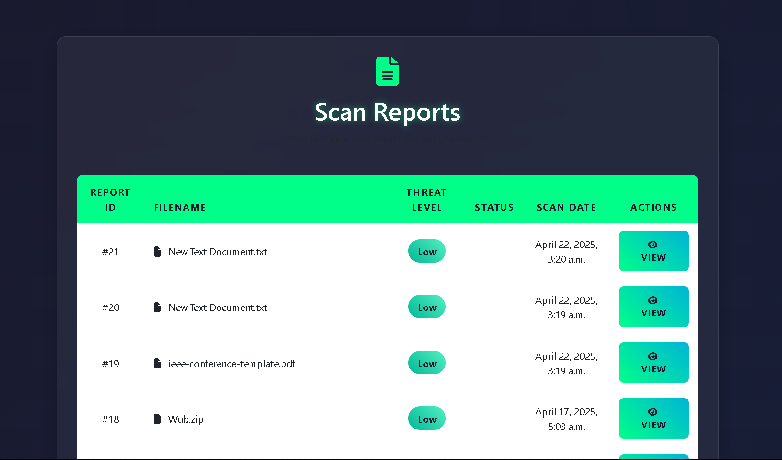

Chapter 6
Testing and Implementation

Testing and Implementation is the ultimate phase of HackShield project to examine if all functionalities are currently being done as expected, if the system behaves stably, securely, and generates good forensic output. Testing ensures if all modules run independently as well as alongside other modules and assist a system in general.

6.1 Implementation Strategy
HackShield was implemented in a modular fashion wherein every module (or code block) was constructed, tested, and rolled out bit by bit. It was developed in the right respect of the Agile paradigm for achieving high iteration speed, round-the-clock feedback, and go-again-and-again efficiency.

Technology Stack Used for Rollout
- Front-end: HTML, CSS, JavaScript
- Back-end: Django (Python) with the relevant libraries like hashlib, cryptography, Pillow, pyexiftool
- Database: SQLite for development, PostgreSQL for production
- Authentication: Authentication module of Django
- Version Control: Git & GitHub

Module-Wise Implementation
Every module (Hash Generator, File Encryptor/Decryptor, Metadata Extractor, Report Generator) was implemented separately. Modules were individually tested and ensured to be working as expected, and modules were progressively combined into a single dashboard system.

6.2 Testing Strategy
1. Unit Testing
Unit testing has been conducted to cross-verify every module separately. Hashing, encryption/decryption, and meta-data extraction operations were verified against different input files (image, PDF, text, etc.) for consistency and correctness.

Example:
- Hash Generator cross-verified correct output with MD5, SHA256.
- Encryption module cross-verified: encrypt → decrypt = original file.
2. Integration Testing
Modules were placed in integration after unit testing to verify whether backend and frontend were performing as expected when combined.
Focus Areas
- Secure storage and listing of the encrypted files
- Verify if reports are being reported after every operation
- Secure persistent handling of users between modules

3. Functional Testing
It is the activity that made the platform function as required. All the behavior of the users was tested as required.
Example Scenarios:
- File can be uploaded with hash to be computed
- Secure encrypted backup of a file with the encryption key
- A report can be reported only once, once activity has been logged
- A user can't view another user's reports or files
4. Security Testing
Because the data (encryption keys, files) is sensitive in nature, security testing was prioritized first.
Key Tests:
- SQL injection protection using Django ORM
- File upload limits (size, type)
- Encryption key management (plaintext storage avoidance)
- Authentication and authorization validation for users

5. Performance Testing
Even load testing was conducted to ensure the platform is not crashing if it is supporting a huge number of users and more than one operation of files being edited at a time.
Sensational Elements of Significance:
- Hash encryption file processing slowdown
- Load user dashboard time when it's operating with an extremely large number of logs
- Parallel user sessions increase
6. Bug Tracking and Fixing
GitHub Issues handled the bug-tracking sheet. All of the bugs that were encountered during testing were reported, given priorities, and fixed step by step.

6.3 Test Case Sample Table:
Test Case ID | Description | Input | Expected Output | Result
TC001 | Generate MD5 Hash | Sample text file | 32-char hash string | Passed
TC002 | Encrypt a File | Sample image & password | Encrypted file download + key shown | Passed
TC003 | Decrypt with Wrong Key | Encrypted file + wrong key | Error message shown | Passed
TC004 | Generate and Download Report | User actions completed | PDF/HTML report download option available | Passed

6.4 Implementation Challenges & Resolutions
Challenge | Resolution
Handling different file types | Used MIME type checking and file-type restrictions
Secure key management | Keys shown once and never stored in plaintext
Large file handling | Streamed uploads and chunked file reading for better performance
Maintaining audit trails | IP, timestamps, and user IDs stored with every action

Chapter 7
Results and Discussion

HackShield: Digital Forensics Kit Development of a website and its testing led to successful implementation of an elegant yet robust web-based digital forensic toolset. The website was thoroughly tested using various modules to ensure verification of its performance, reliability, usability, and functionality, and testing led to high conformity with the desired goals.

7.1 Key Outcomes of the Project
The following are the core results observed during implementation and testing:
Module | Functionality Status | Performance | Accuracy | Remarks
Hash Generator | Fully functional | Fast | 100% | Supports MD5, SHA1, SHA256
File Encryptor/Decryptor | Functional | Moderate | 100% | AES encryption with key sharing
Metadata Extractor | Functional | Fast | 98%+ | Accurate EXIF data extraction
Report Generator | Fully functional | Fast | 100% | Well-structured forensic reports
7.2 Detailed Discussion of Results
1. Hash Generator
- Successfully generated hashes for all tested file types (TXT, PDF, PNG, JPG, DOCX).
- Verified with commercial software like HashCalc and online hash generators.
- No differences found — absolute consistency.

2. File Encryption and Decryption
- Users were able to encrypt files and download encrypted file and key.
- Successful decryption when an active key was present.
- The website encrypted securely without revealing bare keys possessed, with extra security.
- Incorrect key inputs were also handled appropriately with respective error messages.

3. Report Generation
- Upon completion of the forensic operation, the user would have been capable of downloading a report in either PDF or HTML format.
- User data, user action performed by the user, and timestamp were reported along with having easy forensic chain-of-custody.
- User-selectable comments left by the user are cleanly readable on analysis.

4. Security and Privacy
- CSRF protection included with Django, SQL injection, and session hijacking were easy.
- User downloaded files are disabled.
- Everything logged with timestamp and IP address for forensic audit trails.

5. Performance Metrics
- Webpage was also supported for small and medium size files.
- Average:
- Hashing under 1 second.
- Encryption of 2 MB file took 2-3 seconds.
- Metadata extraction under 1 second in almost all the images.

7.3 User Experience & Usability
- UI was user-aware and device-aware.
- Demo test users could use all the modules without any knowledge about them.
- Logical structure of forensic software preserved workflow and introduced increased productivity with pre-conceived layouts.

7.4 Key Insights and Learnings
- Modularity allowed scalability: Scaling one module did not affect others easily.
- Security-by-design was most critical: Particularly for user-uploaded content and encryption keys.
- User access control hand-in-hand with responsibility: The very crux of digital forensic philosophy.
- Libraries took a lot of time and effort from the developers to protect from attacks.

7.5 Limitation Observed
While being very useful, some restrictions that were marked as controversial were:
- Very sluggish processing speeds for large files (>10MB), particularly encrypting them.
- There is no provision for real-time processing or memory forensic analysis as the kit can only process static files.
- No simultaneous access by more than one user at once: The users of each step are treated separately and independently.
- No cloud reporting or forensic file transfer between systems.

Chapter 8
Conclusion and Future Scope

8.1 Conclusion:
HackShield Digital Forensics Kit Web Site was designed and coded module-based, light-weighted, and secure web site for primary use of digital forensics. HackShield successfully achieved primary tasks by developing web-based user-friendly software with primary features such as hash value generation, file encryption and decryption, metadata extraction, and report generation. These are used to a large degree throughout the whole process of forensic analysis to determine the verification of file integrity, assess data confidentiality, and even for recovering concealed digital evidence.

With the use of contemporary web technologies—client-side CSS, JavaScript, and HTML, and server-side Python and Django libraries—the site was put to the test to be scalable, responsive, and stable. The database itself was likewise installed correctly to monitor all the activities of the users, long overdue in having the chain of custody in digital investigations.

Modularity of the platform enabled each module to be written and tested separately prior to loading without interference. The system was warranted and tested on correctness of function, performance, and security as well. On security of higher than authentication level, protection of keys from encryption, restriction of file operations, and end-to-end logging, HackShield is a minimum forensic level requirements of an owned computing application at least.

As a whole, HackShield is a good prototype to offer tutorial demonstration to beginner digital forensic systems. HackShield is an interactive and usable user interface for beginner hobbyists, students, and cybercrime investigators in such a manner that they could receive training and get familiarized with digital forensic practice.

8.2 Future Scope:
While HackShield is now a good forensic utility, there are still possibilities of improvement and updating in the future. After future upgrades would be the software that would be significantly improved in terms of functionality, usability, and user-friendliness among other users:
1. Live Forensics & Memory Analysis
- HackShield now only analyzes static files.
- Future releases can include modules to scan live systems like RAM dumps, running process scan, or open port scan.
- Volatility or Rekall plugins can be included to offer memory forensic features.

2. Cloud Storage & Integration
- Cloud integration (AWS S3, Google Drive) will enable the user to store encrypted files, forensic logs, and reports securely between sessions and machines.
- Remote access and real-time backup can be made possible.

3. Multi-User Collaboration Environment
- The system is currently single-user focused.
- In future releases, role-based design must be accommodated under which various users (supervisors, analysts) must be able to be made to work on a case in an investigation with varying permissions.

4. AI-Based File Analysis
- AI/ML activity can be added to identify anomaly or abuse based on usage (structure, behavior), content, or format.
- It may also encompass auto-tagging of a file to flag as suspicious, normal, or high-risk.

5. Automated Case Management System
- Incorporating a web-based central dashboard for handling multiple forensic cases would be feasible.
- Tagging, sorting, time-stamping, chain of evidence tracking, and note facility would provide efficient investigator workflow.

6. Mobile Compatibility or Mobile App Integration
Where the site is responsive, an app-specific mobile app will provide extendibility, most significantly to field investigators or real-time on-site analysis.

REFRENCES
[1] B. Carrier and E. H. Spafford, “Getting physical with the digital investigation process,” International Journal of Digital Evidence, vol. 2, no. 2, pp. 1–20, Fall 2003.
[2] G. Palmer, “A Road Map for Digital Forensic Research,” Report from the First Digital Forensic Research Workshop (DFRWS), Utica, New York, USA, Aug. 2001.
[3] S. Garfinkel, “Digital forensics research: The next 10 years,” Digital Investigation, vol. 7, pp. S64–S73, Aug. 2010.
[4] B. Schneier, “Applied Cryptography: Protocols, Algorithms, and Source Code in C,” 2nd ed., New York, NY, USA: John Wiley & Sons, 1996.
[5] M. Reith, C. Carr, and G. Gunsch, “An examination of digital forensic models,” International Journal of Digital Evidence, vol. 1, no. 3, pp. 1–12, 2002.
[6] Django Software Foundation, “Django Documentation,” [Online]. Available: https://docs.djangoproject.com/. [Accessed: Apr. 18, 2025].
[7] Open Web Application Security Project (OWASP), “Top 10 Web Application Security Risks,” [Online]. Available: https://owasp.org/www-project-top-ten/. [Accessed: Apr. 18, 2025].
[8] P. Stallings, “Cryptography and Network Security: Principles and Practice,” 7th ed., Pearson Education, 2017.
[9] C. Hargreaves and J. Patterson, “An automated timeline reconstruction approach for digital forensic investigations,” Digital Investigation, vol. 9, no. 2, pp. S69–S79, 2012.
[10] A. Kent and M. Petitcolas, “Digital watermarking and steganography: Techniques for digital forensics,” IEEE Signal Processing Magazine, vol. 26, no. 3, pp. 34–39, May 2009.

